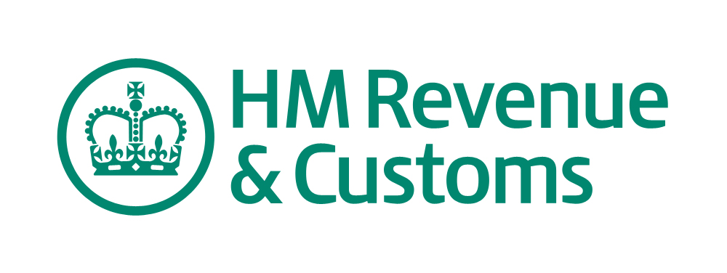

1. GOV.UK website has replaced Business Link and Directgov sites

GOV.UK launched today, initially replacing Business Link and Directgov. This is the first step towards making GOV.UK the definitive website for interacting with central government.

In the meantime, HMRC’s website is still available as a primary source of online support and it’s important to note that there will be no immediate changes to HMRC’s online services such as Self-Assessment Online and PAYE Online.

2. View HMRC online learning to help you deal with disputes and appeals

HMRC has published a new online learning package to aid understanding of HMRC’s resolving disputes - reviews and appeals process.

3. Where to send post
In most cases, agents and advisers can contact HMRC by using the HMRC Online Services, by phone and in writing. When writing to HMRC please reply to the address on the most recent correspondence. Where there is no recent correspondence please use the following addresses:

For Self-Assessment
HM Revenue & Customs
Self-Assessment
PO Box 4000
Cardiff
CF14 8HR
For PAYE or Capital Gains
HM Revenue & Customs
PAYE or Capital Gains Tax
PO Box 1970
Liverpool
L75 1WX

For Corporation Tax
Please write to the office that handles your client's Corporation Tax, using the address on the most recent correspondence. Where there is no recent correspondence, you can use the three-digit Corporation Tax code to find your client's Corporation Tax Office.

4. Post etiquette
HMRC has compiled a list of some commonly used headings to enable correspondence to reach the correct HMRC department. HMRC is asking agents to use these headings when writing about clients' Self-Assessment and PAYE affairs. The Working Together Post Working Group who is running the pilot will provide updates.

5. Find a form
Search for forms, supplementary pages, worksheets and related help and guidance.

6. Toolkits
These toolkits provide guidance on areas of error that HMRC frequently see in returns and set out the steps that you can take to reduce those errors.

If you are already using Toolkits, HMRC would like to hear about your experience. Your comments will be used to help develop and prioritise future changes and improvements to the Toolkits. Please click on the link to complete the new online feedback form. Toolkits Feedback Form

7. Really Simple Syndication (RSS)
Tax agents and advisers can sign up to have the latest news and new web content delivered direct, instead of having to go to a website to find a new article or feature.

8. Learning Together: Videos and Learning material
Videos and online learning modules are available for tax agents and advisers to provide help and support on topical subjects.
Click here to access the new online learning module covering HMRC's reviews and appeals process.
Tax agents and advisers – Booking Learning Together events
Agents who are registered for the Agent Account Manager Service can now book to attend a learning event on using PAYE in real time.

10. Online seminars for businesses and the self-employed
HMRC are now running online presentations (webinars) that provide help & support for businesses. These webinars will complement the support provided by their agent and will cover a variety of subjects including Self-assessment, VAT, Payroll and International Trade.

The AAM service will send further information at times throughout the year to those agents who have registered.

Agents who have not already registered for the service can sign up here.
Register to use the AAM Service

End of bulletin

